TRADE OF PLASTERING

PHASE 2

Module2
External Work

UNIT: 3

Plinth and Fine Float Finish Wall

Produced by

In cooperation with subject matter expert:
Terry Egan
Some images & text courtesy of Gypsum Industries Ltd.
© SOLAS
Table of Contents
Introduction 1
Unit Objective 1
1.0 Suitable External Finishes for Damp Proofing 2
1.1 Water Proofing/Dampness and Capillary Action 2
1.2 External Finishes 2
2.0 Interpret and Draw Recessed And Projecting Plinths 4
2.1 Draw Elevation of Walls with Recessed And Projecting Plinth 4

Introduction
Welcome to this section of your course which is designed to introduce you the learner, damp proofing and drawing plinths.

Unit Objective
By the end of this unit each apprentice will be able to:
- Select suitable external finishes for damp proofing qualities
- Interpret and draw recessed and projecting plinths

1.0 Suitable External Finishes for Damp Proofing

Key Learning Points
- Water proofing/dampness and capillary action
- External finishes - functions, types, properties etc.

1.1 Water Proofing/Dampness and Capillary Action

Water Proofing/Dampness
Part of a plasterer work is to prevent rainwater from gaining access to the building by adding a water proofer to the mix either in liquid or powder form making sure to follow manufactures specifications.

Capillary Action
Capillary attraction is the way by which water can pass through a solid object, such as brick or stone and even can rise between two sheets of metal fitted close together.

1.2 External Finishes
No matter what type of external finish is required, it will be necessary to protect surrounding areas. It is essential to ‘mask-up’ all brickwork, doors and windows. Stains cannot be washed off brickwork and damage to completed work will occur. Washing of brickwork will leave a smeary stain which is impossible to remove. When the job is complete, remove the protective material carefully. If windows and doors have to be washed it is important not to let water run off sills or splash on to completed work.

Plain-face Rendering
For best results, all external work should be carried out in two-coat work, not stronger than 3 to 1 and no weaker than 6 to 1, additives are sometimes required. The suction of the background must be checked this can be done by applying water to a small area of the wall. If the water is immediately absorbed, there is a high suction. If the water remains visible, or runs down the wall, the suction is low. In either case a light application of water will be advantageous.
During hot summer conditions it is very nice to be in the sun, but more beneficial to carry out the work in the shade by starting on the west-facing wall in the morning and following on with the north, east and then the south walls. This will help to prevent the walls from drying too quickly.
When applying the first coat of rendering start at the top and work down. This first coat should be about 10 mm in thickness and lightly rule off to remove any high spots. Having done this, you must key the wall for the next coat. This can be done with a home-made wire or nail scratcher.
At the base of the wall a bell-cast or projecting plinth is formed. This can be done using pre-formed metal sections, or with rules. If the work goes right down to ground level it is best to remove some soil from around the building, so that the work goes lower than required. After the job is complete the soil can be returned when the work is hard, to leave a nice neat appearance. It is, however, not a good idea to ‘bridge’ a damp course, unless a waterproof liquid is used in the mix. The second coat of rendering should not be applied the same day. The mix for the second coat should be the same mix or gauge as the first coat or weaker. Before applying the second coat, lightly dampen the wall. This is particularly important during hot weather. To prevent the work drying out too quickly, work in pairs when possible – one plasterer applying and ruling off, and the second doing the finishing, or rubbing up, and cleaning off.

Rough Castings
This is a type of external textured finish in which pebbles or crushed stones of suitable size are mixed with a cement mortar and thrown on to the wall as a wet dash.
The distinction between pebble dashing and rough casting is that in the former dry pebbles are thrown on to a soft dashing coat, whilst in rough casting the wet mix is thrown on to a dry rendering.
The latter method ensures a much stronger job which will outlast pebble dashing by many years. This is due partly to the fact that the pebbles are completely enveloped by the matrix, and also that maximum adhesion is ensured by throwing on to the wall instead of application by trowel.
The texture achieved by rough casting is generally considered to be inferior to that of pebble dashing, though many prefer its more rugged effect.

2.0 Interpret and Draw Recessed And Projecting Plinths

Key Learning Points
- Elevation of walls with recessed and projecting plinth

2.1 Draw Elevation of Walls with Recessed And Projecting Plinth
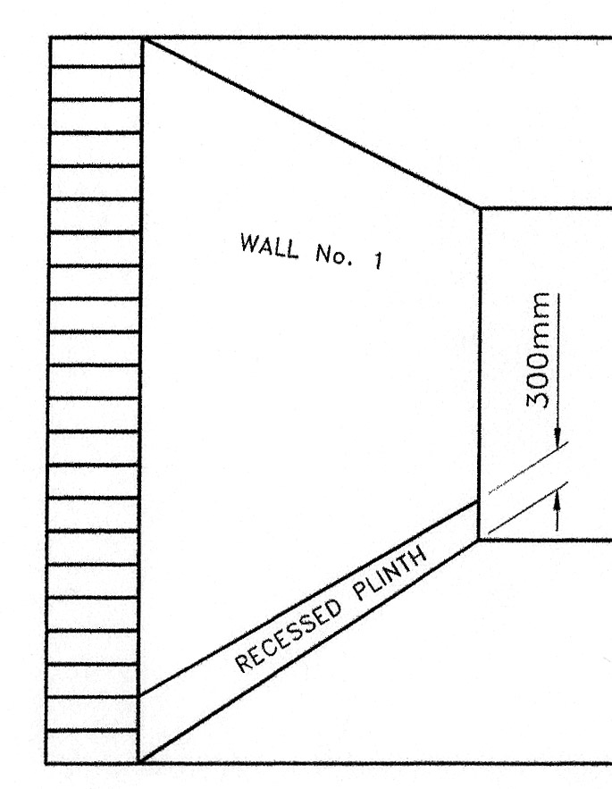
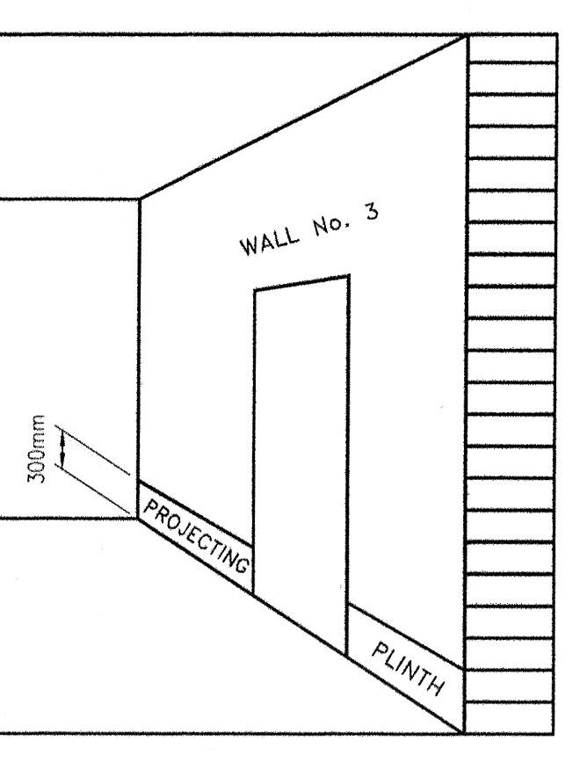
Recessed Plinth Projecting Plinth

27-33 Upper Baggot Street
Dublin 4

